

**UR Viswaanand** (Erasmus student)

COURSE: DATABASES

ASSIGNMENT 11

NORMALIZATION

SQL SERVER MANAGEMENT STUDIO

2018

**Theory Part**

**Proceed to Third Normal Form, 3 NF. Based on 3 NF what kind of tables would you create to SQL Server environment**?

There are three main reason to proceed normalize a database

* First is to minimize duplicate data,
* Second is to minimize or avoid data modification issues.
* Third is to simplify queries.
* Normalization is executed as a series of steps.
* Each step corresponds to a specific normal form that has known properties.
* As normalization proceeds, the relations become progressively more restricted (stronger) in format and less vulnerable to update anomalies.
* The relational data model, it is important to recognize that it is only the First Normal Form (1 NF) that is critical in creating relations;
* To avoid the renew anomalies it is generally recommended that we proceed to at least Third Normal Form (3 NF).

The process of normalization by first transferring the data from the source (for example, a standard data entry form) into table format with rows and columns.

**E.g from Net:**

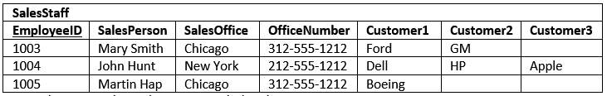

The first thing to notice is this table serves many purposes including:

1. Identifying the organization’s salespeople
2. Listing the sales offices and phone numbers
3. Associating a salesperson with an sales office
4. Showing each salesperson’s customers

As a DBA, this raises a red flag.  In general, I like to see tables that have one purpose.  Having the table serve many purposes introduces many of the challenges; namely, data duplication, data update issues, and increased effort to query data.

#### Insert Anomaly

There are facts we cannot record until we know information for the entire row.  In our example we cannot record a new sales office until we also know the sales person.  Why?  Because in order to create the record, we need provide a primary key.  In our case this is the EmployeeID.

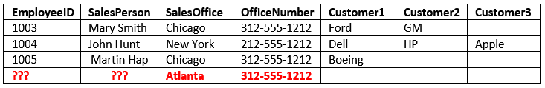

#### Update Anomaly

The same information is recorded in multiple rows.  For instance if the office number changes, then there are multiple updates that need to be made.  If these updates are not successfully completed across all rows, then an inconsistency occurs.

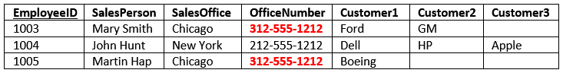

#### Deletion Anomaly

Deletion of a row can cause more than one set of facts to be removed.  For instance, if John Hunt retires, then deleting that row cause use to lose information about the New York office.

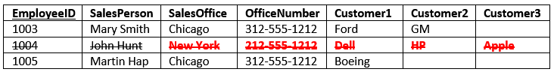

Referece: <https://www.essentialsql.com/get-ready-to-learn-sql-database-normalization-explained-in-simple-english/>

<https://www.essentialsql.com/get-ready-to-learn-sql-11-database-third-normal-form-explained-in-simple-english/>

----------------------------------------------------------------------------------------------------

**Our Task:**

If we compare this example to our task that really understandable for me to continue the next step,that is to explain through diagram.

|  |  |  |  |  |  |
| --- | --- | --- | --- | --- | --- |
| SocialSecurityNumber | Employee | ContractNumber | HoursDone | TargetName | TargetAddress |
| 051159-056G | Adela Banner | 201401 | 16 | Mikpoli | Patteristonkatu 3 |
| 110684-0056 | Ellis Holt | 201401 | 22 | Mikpoli | Patteristonkatu 3 |
| 110684-0056 | Ellis Holt | 201402 | 27 | Päämajakoulu | Otto Mannisenkatu 10 |
| 110682-112F | Ralf Cockburn | 201403 | 14 | Akseli | Hallituskatu 7-9 |
| 110682-112F | Ralf Cockburn | 201404 | 33 | Elomaan Talo | Pirttiniemenkatu 7 |
| 081169-167S | Jerome Palmer | 201404 | 15 | Elomaan Talo | Pirttiniemenkatu 7 |
| 230899-178K | Hammond Danniel | 201405 | 21 | Mikkelin Kuntopalvelu | Savilahdenkatu 16 |
| 230899-178K | Hammond Danniel | 201406 | 37 | Mikkelin I Apteekki | Porrassalmenkatu 1 |
| 031295-132D | Cathleen Forrest | 201407 | 11 | RengasCenter | Juvantie 77 |
| 073078-234N | Kimmy Terrell | 201407 | 25 | RengasCenter | Juvantie 77 |

### 

### This mind map show the connection between the other tables and columns,

### 

A1

fd3

fd4

A2

A4

A3

|  |  |  |  |  |  |
| --- | --- | --- | --- | --- | --- |
| SocialSecurityNumber | ContractNumber | Employee | HoursDone | TargetName | TargetAddress |
| 051159-056G | 201401 | Adela Banner | 16 | Mikpoli | Patteristonkatu 3 |
| 110684-0056 | 201401 | Ellis Holt | 22 | Mikpoli | Patteristonkatu 3 |
| 110684-0056 | 201402 | Ellis Holt | 27 | Päämajakoulu | Otto Mannisenkatu 10 |
| 110682-112F | 201403 | Ralf Cockburn | 14 | Akseli | Hallituskatu 7-9 |
| 110682-112F | 201404 | Ralf Cockburn | 33 | Elomaan Talo | Pirttiniemenkatu 7 |
| 081169-167S | 201404 | Jerome Palmer | 15 | Elomaan Talo | Pirttiniemenkatu 7 |
| 230899-178K | 201405 | Hammond Danniel | 21 | Mikkelin Kuntopalvelu | Savilahdenkatu 16 |
| 230899-178K | 201406 | Hammond Danniel | 37 | Mikkelin I Apteekki | Porrassalmenkatu 1 |
| 031295-132D | 201407 | Cathleen Forrest | 11 | RengasCenter | Juvantie 77 |
| 073078-234N | 201407 | Kimmy Terrell | 25 | RengasCenter | Juvantie 77 |

### One candidate key for being a primary key are attributes SocialSecurityNumber and ContactNumber:

### To transform the 1 NF relation into 2 NF requires the creation of new relations so that the non-primary –key attributes are removed along with a copy of the part of the primary key on which they are fully functionally dependent:

### Employee(SocialSecurityNumber, Employee)

### Contract(ContractNumber, TargetName, TargetAddress)

### WorkDone(SocialSecurityNumber, ContractNumber, HoursDone)

### Employee:

|  |  |
| --- | --- |
| SocialSecurityNumber | Employee |
| 051159-056G | Adela Banner |
| 110684-0056 | Ellis Holt |
| 110682-112F | Ralf Cockburn |
| 081169-167S | Jerome Palmer |
| 230899-178K | Hammond Danniel |
| 031295-132D | Cathleen Forrest |
| 073078-234N | Kimmy Terrell |

### Contract:

|  |  |  |
| --- | --- | --- |
| ContractNumber | TargetName | TargetAddress |
| 201401 | Mikpoli | Patteristonkatu 3 |
| 201402 | Päämajakoulu | Otto Mannisenkatu 10 |
| 201403 | Akseli | Hallituskatu 7-9 |
| 201404 | Elomaan Talo | Pirttiniemenkatu 7 |
| 201405 | Mikkelin Kuntopalvelu | Savilahdenkatu 16 |
| 201406 | Mikkelin I Apteekki | Porrassalmenkatu 1 |
| 201407 | RengasCenter | Juvantie 77 |

### WorkDone:

|  |  |  |
| --- | --- | --- |
| SocialSecurityNumber | ContractNumber | HoursDone |
| 051159-056G | 201401 | 16 |
| 110684-0056 | 201401 | 22 |
| 110684-0056 | 201402 | 27 |
| 110682-112F | 201403 | 14 |
| 110682-112F | 201404 | 33 |
| 081169-167S | 201404 | 15 |
| 230899-178K | 201405 | 21 |
| 230899-178K | 201406 | 37 |
| 031295-132D | 201407 | 11 |
| 073078-234N | 201407 | 25 |

### To transform the Contract relation into 3 NF, you must first remove transitive dependency (fd4) by creating two new relations:

### Contract(ContractNumber, TargetName)

### Target(TargetName, TargetAddress)

### Now the relations are:

### Employee:

|  |  |
| --- | --- |
| SocialSecurityNumber | Employee |
| 051159-056G | Adela Banner |
| 110684-0056 | Ellis Holt |
| 110682-112F | Ralf Cockburn |
| 081169-167S | Jerome Palmer |
| 230899-178K | Hammond Danniel |
| 031295-132D | Cathleen Forrest |
| 073078-234N | Kimmy Terrell |

### Contract:

|  |  |
| --- | --- |
| ContractNumber | TargetName |
| 201401 | Mikpoli |
| 201402 | Päämajakoulu |
| 201403 | Akseli |
| 201404 | Elomaan Talo |
| 201405 | Mikkelin Kuntopalvelu |
| 201406 | Mikkelin I Apteekki |
| 201407 | RengasCenter |

### Target:

|  |  |
| --- | --- |
| TargetName | TargetAddress |
| Mikpoli | Patteristonkatu 3 |
| Päämajakoulu | Otto Mannisenkatu 10 |
| Akseli | Hallituskatu 7-9 |
| Elomaan Talo | Pirttiniemenkatu 7 |
| Mikkelin Kuntopalvelu | Savilahdenkatu 16 |
| Mikkelin I Apteekki | Porrassalmenkatu 1 |
| RengasCenter | Juvantie 77 |

### WorkDone:

|  |  |  |
| --- | --- | --- |
| SocialSecurityNumber | ContractNumber | HoursDone |
| 051159-056G | 201401 | 16 |
| 110684-0056 | 201401 | 22 |
| 110684-0056 | 201402 | 27 |
| 110682-112F | 201403 | 14 |
| 110682-112F | 201404 | 33 |
| 081169-167S | 201404 | 15 |
| 230899-178K | 201405 | 21 |
| 230899-178K | 201406 | 37 |
| 031295-132D | 201407 | 11 |
| 073078-234N | 201407 | 25 |

### Practical Part

### Tables and Columns Output in SQL Server:

### Employee Table:

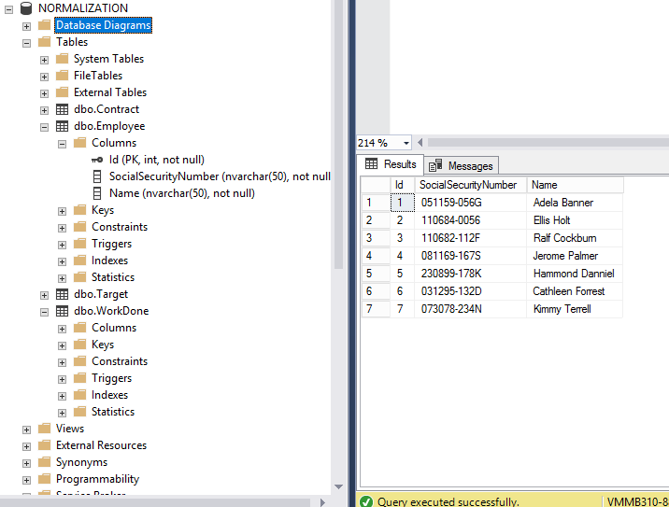

### Contract Table:

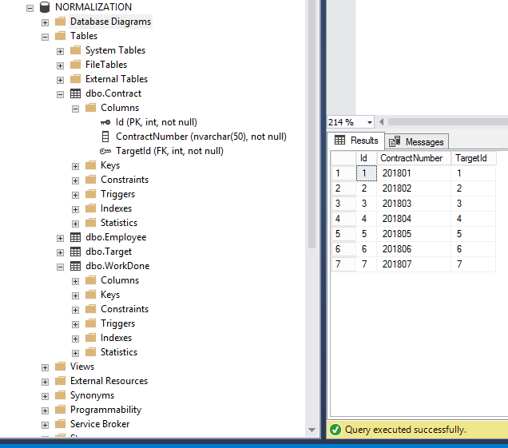

### Target Table:

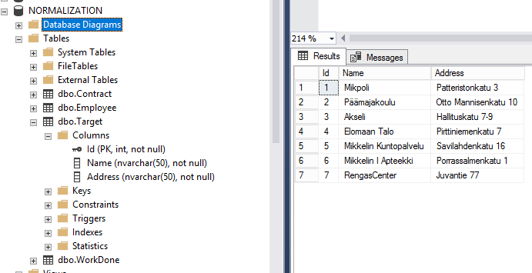

### WorkDone Table:

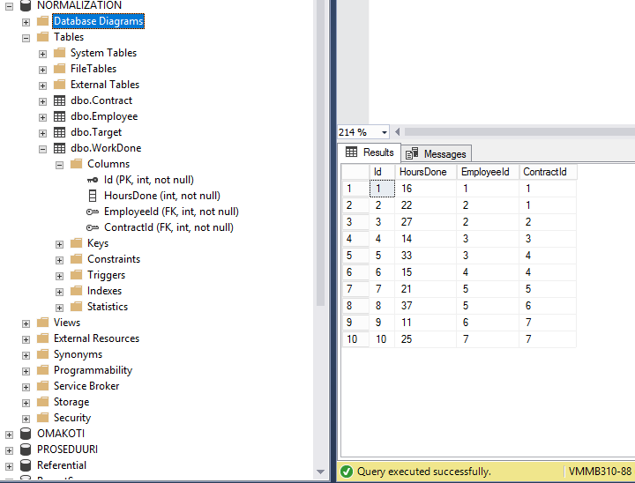

DATABASE DIAGRAM EXTRA:

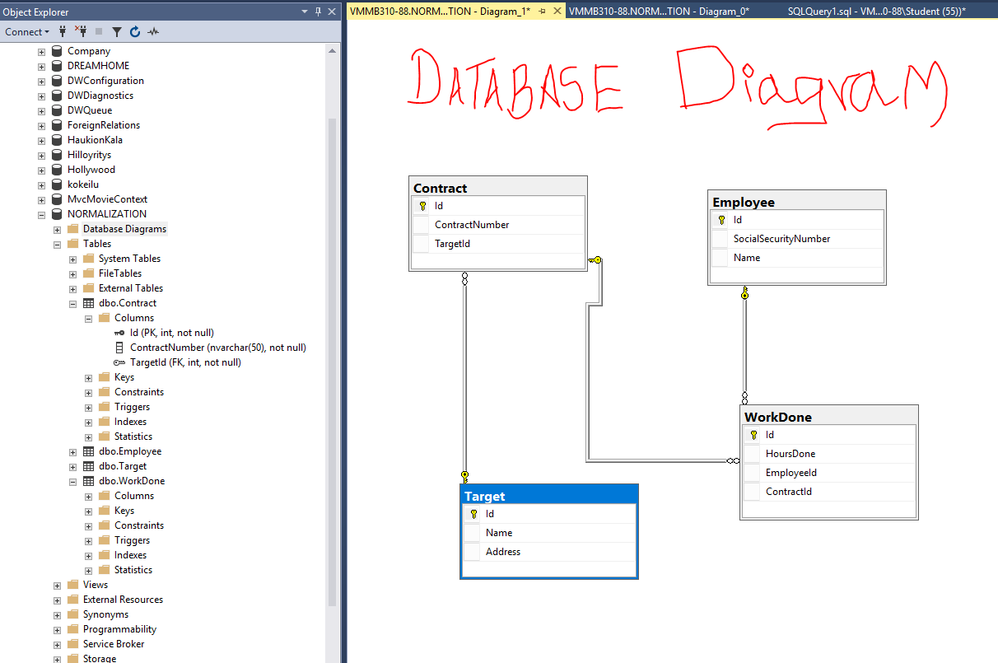

I mentioned as far I know in my knowledge sir, Thanks for your consideration. Kiitos!!